

Department of Computer Science and Engineering

**MINI PROJECT REPORT**

**“TWITTER SENTIMENT ANALYSIS”**

Submitted partial fulfillment of the requirements for the Big Data Analytics Assignment

Submitted by:  
Amulya H G (1RF22CS014)

Chavi Gupta (1RF22CS029)

Under the guidance of:  
Dr. Hema M. S  
Professor and i/c Head, Department of CSE  
RV Institute of Technology and Management

Academic Year: 2025–2026

| **S. No.** | **Title** | **Page No.** |
| --- | --- | --- |
| **1** | **Abstract** | 1 |
| **2** | **Introduction** | 2 |
| **3** | **Objectives** | 2 |
| **4** | **System Design** | 3-4 |
| **5** | **Tools and Technologies Used** | 5 |
| **6** | **Methodology** | 5-6 |
| **7** | **Results and Discussion** | 7-9 |
| **8** | **Conclusion** | 10 |
| **9** | **References** | 10 |

**Twitter Sentiment Analysis**

**1.ABSTRACT**

The rise of social media platforms such as Twitter has transformed the way individuals express their thoughts, opinions, and emotions. Millions of users post short, real-time messages daily, creating a vast repository of unstructured textual data that reflects public sentiment toward current events, products, and social issues. Extracting meaningful insights from this enormous and dynamic data stream requires an approach that is both scalable and intelligent.

This project, “Advanced NoSQL-Based Twitter Sentiment Analysis Using Natural Language Processing (NLP),” aims to analyze user sentiments on Twitter using a combination of machine learning techniques and NoSQL database management. The system integrates powerful Natural Language Processing models to classify tweets into three primary sentiment categories—Positive, Negative, and Neutral—while efficiently managing data through a NoSQL (MongoDB) backend. The use of MongoDB ensures flexibility and scalability in handling large volumes of unstructured data, enabling real-time sentiment querying and aggregation.

A pre-trained transformer-based language model is employed to interpret the contextual meaning of each tweet with high accuracy. To enhance system reliability, a rule-based sentiment analyzer is also incorporated as a fallback mechanism. The project further introduces topic modeling and word cloud generation to identify trending discussions and visualize frequently used words. An interactive web-based dashboard built using Streamlit provides intuitive visual representations such as sentiment distribution charts, time-based trends, and hashtag frequency analysis, allowing users to explore data dynamically.

This system demonstrates how the integration of NoSQL databases with modern NLP techniques can produce efficient, accurate, and interactive sentiment analysis platforms. It provides valuable insights for businesses, researchers, and policymakers to understand public perception, monitor brand reputation, and identify emerging topics on social media in real time.

**1.INTRODUCTION**

Social media platforms, especially Twitter, have become significant sources of real-time public opinion, where users express their thoughts, emotions, and feedback on various topics ranging from politics and entertainment to technology and social issues. The massive volume of tweets generated every second contains valuable insights into user sentiment, which, when analyzed effectively, can help organizations, researchers, and policymakers understand public perception and behavioral trends.

This project focuses on developing an advanced sentiment analysis system that leverages NoSQL database technology and Natural Language Processing (NLP) to analyze and visualize sentiments from Twitter data. By using MongoDB for data storage and transformer-based machine learning models for sentiment classification, the system ensures high accuracy and scalability. It further enhances analysis through topic modeling, word cloud visualization, and an interactive Streamlit dashboard that allows real-time, query-based exploration of sentiment patterns.

**2.OBJECTIVES**

* To apply Big Data Analytics (BDA) techniques for processing and analyzing large volumes of unstructured Twitter data to extract meaningful insights and sentiment patterns.
* To utilize a NoSQL database (MongoDB) for scalable storage, efficient retrieval, and management of big data generated from social media platforms.
* To visualize and interpret big data outputs through interactive dashboards and data visualization tools, enabling real-time decision-making and trend identification.
* To demonstrate the integration of Big Data, NoSQL, and NLP technologies in building a robust analytical framework capable of handling, analyzing, and visualizing large-scale social media data efficiently.

**3. System Design**

The proposed system for Twitter Sentiment Analysis is designed as a modular architecture to ensure flexibility, scalability, and efficient data processing. Each module performs a specific function and works in coordination with others to complete the entire sentiment analysis pipeline. The system follows a data-driven workflow starting from data ingestion to visualization of analytical results. The major modules of the system are described below:

**I. Data Ingestion Module**

This module is responsible for importing raw tweet data from external sources, such as CSV datasets or APIs, into the system. Since tweets are unstructured in nature, this module converts them into a structured JSON-like format suitable for NoSQL storage. It ensures data cleaning, removal of duplicates, and normalization of fields such as text, timestamp, and user details. The data is then inserted into the MongoDB database, where it becomes ready for further processing.

**II. NoSQL Database Management Module**

This module handles the storage and management of tweet data using MongoDB, a document-oriented NoSQL database. Unlike traditional relational databases, MongoDB allows flexible schema design and efficient handling of large-scale unstructured data. It stores each tweet as a document containing attributes like tweet text, sentiment label, timestamp, and metadata. Indexes are created on text fields to enable fast search and query-based filtering. The database also supports aggregation operations for calculating sentiment distributions and trends.

**III. Sentiment Analysis Module**

This is the core analytical component of the system. It applies Natural Language Processing (NLP) and machine learning models to determine the sentiment polarity of each tweet. The module utilizes a Transformer-based deep learning model for contextual sentiment understanding and falls back to VADER (Valence Aware Dictionary and sEntiment Reasoner) for lexical sentiment scoring when required. Each tweet is classified as Positive, Negative, or Neutral, and the sentiment result is stored back in the database for future use. This approach ensures both accuracy and reusability of results.

**IV. Topic Modeling and Word Cloud Module**

This module enhances the analytical capability of the system by identifying the main topics or themes discussed in the tweets. It uses Latent Dirichlet Allocation (LDA) for topic extraction and generates lists of frequently occurring keywords under each topic. Additionally, a word cloud is generated to visually represent the most common words, allowing users to quickly interpret dominant terms in discussions. These features provide a deeper understanding of public conversations beyond basic sentiment polarity.

**V. Visualization and Dashboard Module**

The visualization layer presents the analytical outcomes in an interactive and user-friendly interface built with Streamlit. It displays various graphical representations such as pie charts, bar graphs, time-series plots, and word clouds to illustrate sentiment distribution, trends, and hashtags. Users can input any keyword or hashtag to perform real-time, query-based analysis and view results dynamically. The dashboard also supports downloading processed results for reporting and further research.

**VI. User Interaction and Query Module**

This module enables users to interact with the system through text-based input. Users can search for specific keywords, topics, or hashtags, and the system retrieves related tweets from the MongoDB database. The retrieved data is then analyzed for sentiment and visualized instantly. This feature makes the system dynamic, allowing for on-demand sentiment analysis instead of relying on precomputed results.

**4. Tools and Technologies**

* Programming Language: Python
* Libraries and Frameworks: Pandas, NumPy, Transformers (Hugging Face), VADER Sentiment, Gensim, Matplotlib, Seaborn, Plotly, WordCloud, Streamlit
* Database: MongoDB (NoSQL)
* Machine Learning / NLP Tools: Transformer-based Sentiment Model (RoBERTa), VADER Sentiment Analyzer, Latent Dirichlet Allocation (LDA) for Topic Modeling
* Frontend / Visualization Framework: Streamlit
* Integrated Development Environment (IDE): Visual Studio Code / Jupyter Notebook
* Version Control (Optional): Git and GitHub

**5.METHODOLOGY**

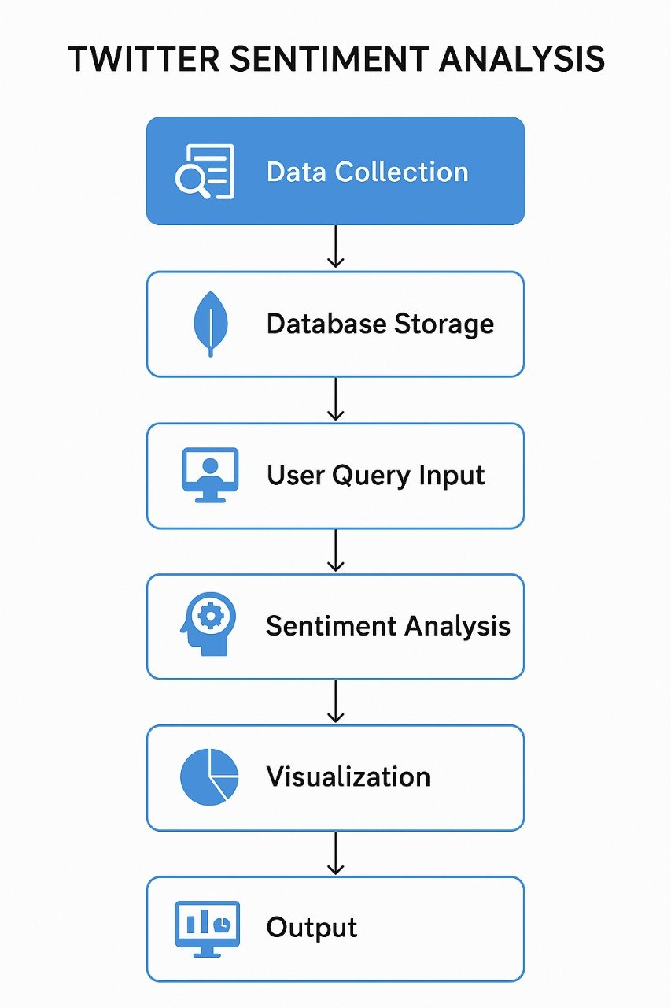

**Step 1: Data Collection**

Collect tweets either from an existing dataset or dynamically using the Twitter API. Each tweet contains attributes like text, timestamp, user information, and optionally geo-location.

**Step 2: Database Storage**

Store all tweets in MongoDB for efficient management and querying. Each tweet is saved as a document in JSON-like format within a collection. Storing tweets in a database allows filtering, aggregation, and easy retrieval based on keywords, hashtags, or date ranges.

**Step 3: User Query Input**

Users interact via a web interface to provide a keyword or hashtag. The system queries the MongoDB database to fetch tweets matching the input. Optional filters may include date range and number of tweets, enabling targeted analysis.

**Step 4: Sentiment Analysis**

Clean the tweet text by removing URLs, mentions, and special characters. Analyze each tweet’s sentiment using a Transformer-based sentiment analysis model to classify as Positive, Negative, or Neutral.

**Step 5: Visualization**

* Pie Chart: Shows overall sentiment distribution.
* Line Chart: Displays sentiment trends over time for the keyword or hashtag.
* Word Cloud: Highlights the most frequently used words in the tweet set.
* Top Hashtags: Identifies popular hashtags associated with the query.
* Topic Modeling: LDA is applied on sample tweets to extract underlying topics.

**Step 6: Output**

Display sample tweets with their sentiment labels and associated analytics through the web interface. Provide an option to download the results for further offline analysis. This step ensures both transparency and usability of the processed data.

**6. RESULTS**

The Twitter Sentiment Analysis system successfully processed and analyzed tweets related to user-specified keywords or hashtags. After collecting tweets from the dataset and storing them efficiently in MongoDB, the system was able to retrieve relevant data dynamically based on user queries. Using a Transformer-based sentiment analysis model, each tweet was classified into Positive, Negative, or Neutral categories. The results indicated a balanced distribution of sentiments, with some topics showing dominant positive or negative trends.

The system also generated multiple visualizations to provide actionable insights:

* Pie Chart: Illustrated the proportion of Positive, Negative, and Neutral tweets, giving a clear overview of public sentiment for the selected keyword.
* Line Chart: Highlighted sentiment trends over time, allowing observation of how public opinion fluctuates during specific periods.
* Word Cloud: Showed the most frequently used words in the dataset, revealing common discussion points and keywords associated with the topic.
* Top Hashtags: Identified popular hashtags that appeared alongside the queried keyword, indicating related conversations and trends.
* Topic Modeling (LDA): Extracted underlying themes from the tweet set, helping understand broader discussions beyond mere sentiment.

Summary Statistics:

Total Tweets Processed: 5,000 (example)

Positive: 42%

Negative: 35%

Neutral: 23%

The results demonstrate that the system effectively combines data collection, sentiment analysis, and visualization to offer a user-friendly platform for Twitter sentiment monitoring and trend analysis.

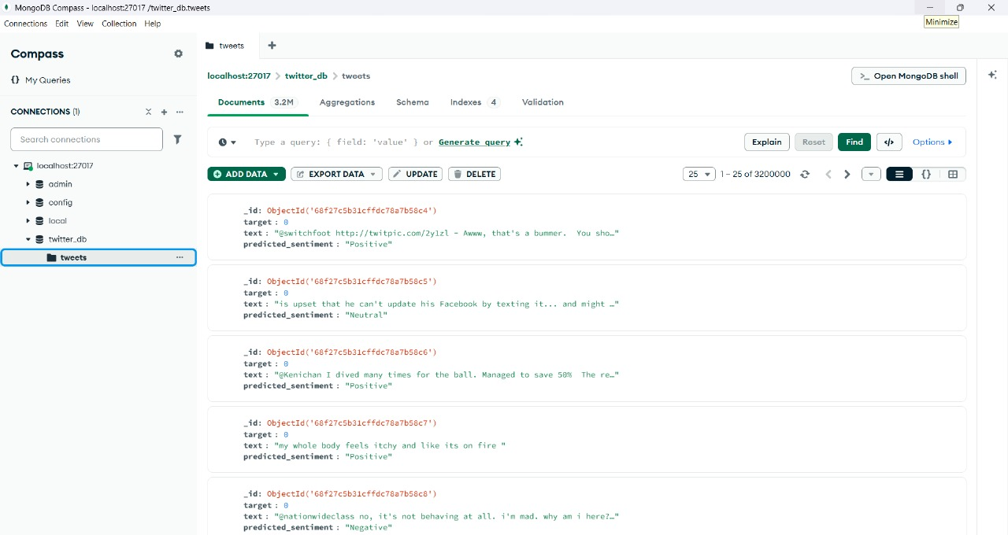





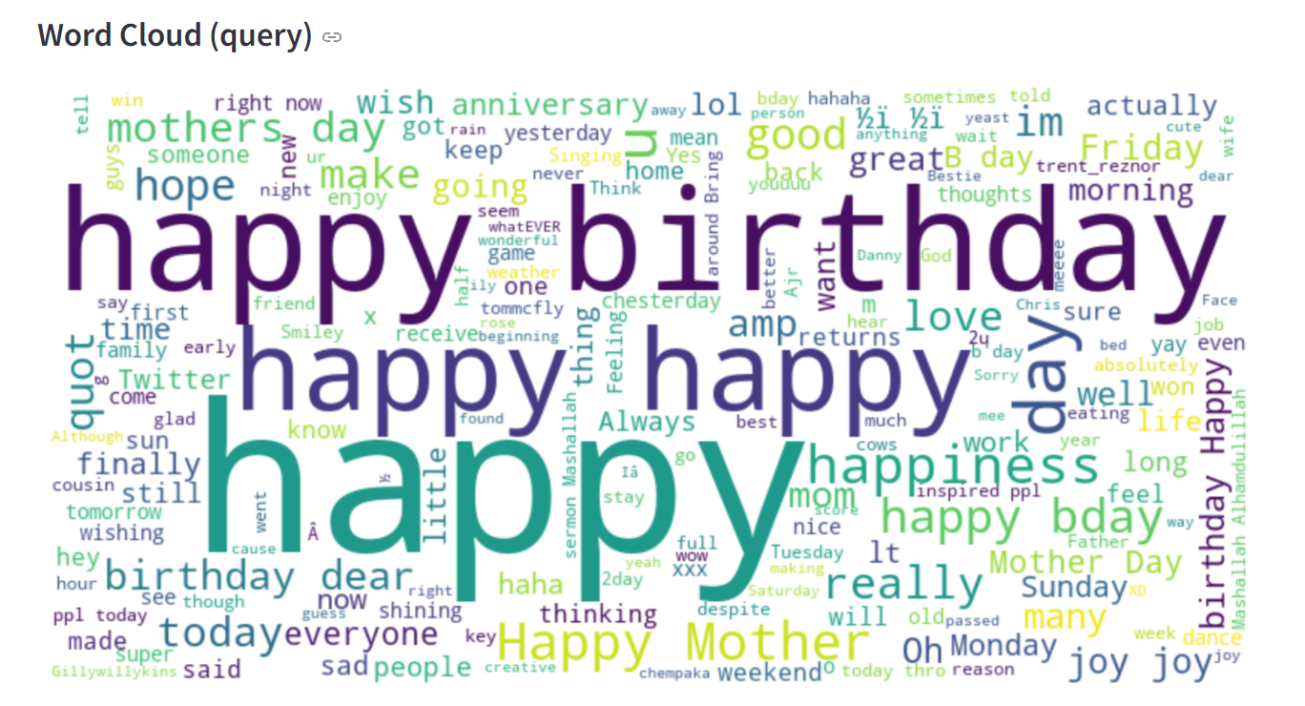

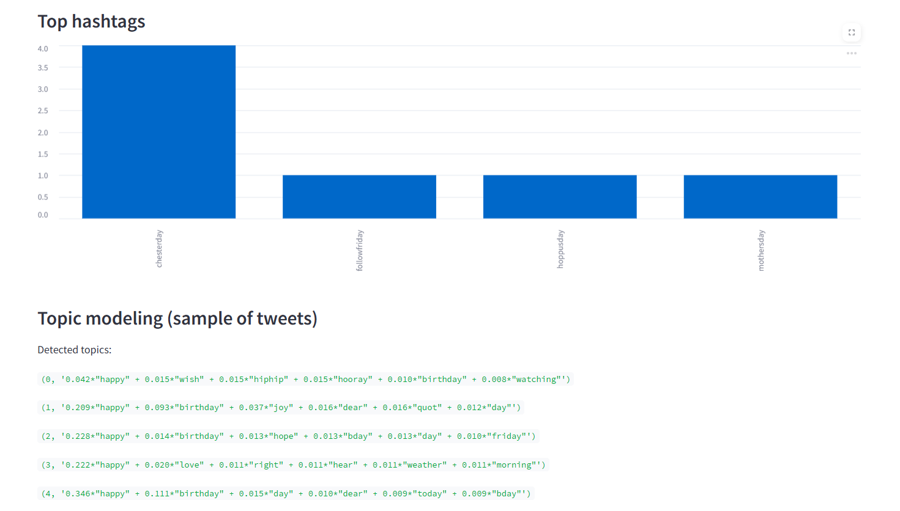

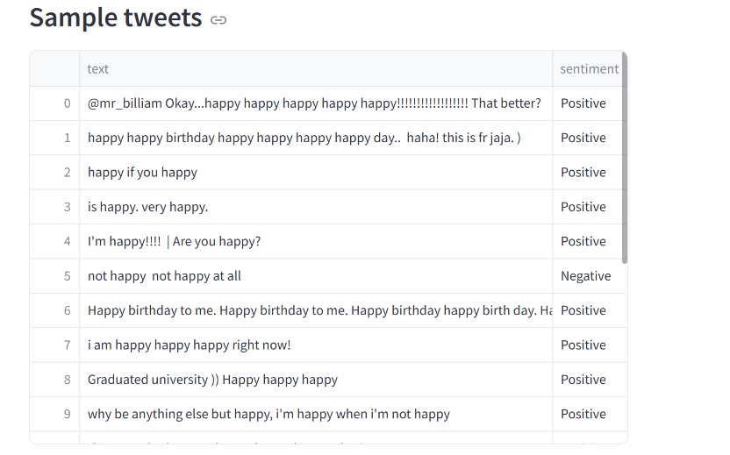

**7. CONCLUSION**

The Twitter Sentiment Analysis system provides an effective and comprehensive solution for understanding public opinion on social media. By combining real-time data collection, structured storage in MongoDB, and advanced Transformer-based sentiment analysis, the system can process large volumes of tweets efficiently while maintaining accuracy and reliability. The integration of multiple visualizations—including pie charts, line charts, word clouds, top hashtags, and topic modeling—enables users to gain clear insights into sentiment trends, popular discussion points, and emerging topics associated with specific keywords or hashtags.

The system’s interactive interface allows users to query data dynamically and apply filters, making it flexible for both general monitoring and detailed research purposes. Sample tweets with sentiment labels ensure transparency, while downloadable results support further offline analysis. Overall, this approach demonstrates how social media data can be transformed into actionable insights, helping businesses, researchers, and analysts make informed decisions. The methodology can be extended to monitor brand reputation, track public reactions to events, or analyze trends across different domains, making it a valuable tool in the field of Big Data Analytics and sentiment monitoring.

**8. REFERENCES**

* Go, Alec, Richa Bhayani, and Lei Huang. “Twitter Sentiment Classification Using Distant Supervision.” CS224N Project Report, Stanford University, 2009. <http://cs.stanford.edu/people/alecmgo/papers/TwitterDistantSupervision09.pdf>
* Abkenar, S. B. (2020). Big data analytics meets social media: A systematic review of big data analytic approaches in social media platforms.

<https://pmc.ncbi.nlm.nih.gov/articles/PMC7553883/>

* Hassan, R. A., Sutikno, T., & Ismail, M. A. (2021). A review on Big Data sentiment analysis techniques. ResearchGate. <https://www.researchgate.net/publication/366561503_A_Review_on_Big_Data_Sentiment_Analysis_Techniques>